Lesson Plan Coil Structures Length: 2 ½ Weeks

Course Name | 3D Design | Grade Level | 9th-12th grade

Enduring Understanding (s):  (Statements summarizing important idea(s) and core process(es) that are central to an art topic and have lasting value beyond the classroom. They synthesize what students should understand—not just know or do—as a result of studying a particular area of art. Moreover, they articulate what students should “revisit” over the course of their lifetimes in relationship to art. These statements link two or more concepts.) | Prepared Graduate Competency (ies):  (List, in bullet form, which Prepared Graduate Level Competency [ies] will be addressed in this lesson as it [they] relate [s] to the enduring understanding [s].)
Artists use the inherent characteristics and expressive features of art to communicate meaning.  (Comprehend)  Artists and designers explore materials to make art in all its forms.  (Create) | Comprehend:  -Make informed critical evaluations of visual material culture, information, and technologies  ¬ Recognize, interpret, and validate that the creative process builds on the development of ideas through a process of inquiry, discovery, and research  Reflect:  -Recognize, compare, and affirm that the making and study of art and design can be approached from a variety of viewpoints, intelligences, and perspectives  ¬ Use specific criteria to discuss and evaluate works of art  Create:  -Create works of art that articulate more sophisticated ideas, feelings, emotions, and points of view about art and design through an expanded use of media and technologies  ¬ Recognize, articulate, and implement critical thinking in the visual arts by synthesizing, evaluating, and analyzing visual information  Transfer:  -Identify, compare and justify that the visual arts are a way to acknowledge, exhibit and earn about the diversity of peoples, cultures and ideas

Objectives/Outcomes/Learning Targets: Student will be able to... (Measurable)
(Aligned to: Bloom’s-Standards-GLEs/ and, when appropriate, Numeracy, Literacy and Technology. Should be written as: Objective. Bloom’s: _____ - Standard: _____ - GLE: _____. Numeracy, Literacy, and/or Technology)
- Given demonstration, TSWBAT successfully glaze a ceramic piece to finish their coil pot.
(Bloom’s: Analyze, Standard: Comprehend, GLE: 1.1 Visual art has inherent characteristics and expressive features, Literacy, Technology)

- Using the coil method TSWBAT create a 10” vessel that follows a chosen theme.
(Bloom’s: Analyze, Standard: Create, GLE: 3.2 Assess and produce art with various materials and methods, Numeracy, Technology)

- After viewing a variety of structures, TSWBAT create 3 preliminary sketches that follow a theme.
(Bloom’s: Create, Standard: Create, GLE: 3.3 Make judgments from visual messages, Numeracy, Technology)

- Given a PowerPoint presentation, TSWBAT depict a theme to inspire their coil pot.
(Bloom’s: Remembering, Standard: Reflect, GLE: 2.1 Reflective strategies are used to understand the creative process, Technology)

- Using provided template, TSWBAT discuss art pieces to reflect on their work and the work of others
(Bloom’s: Evaluate, Standard: Transfer: GLE: 4.2 Communication through advanced visual methods is a necessary skill in everyday life, Literacy)

Pre-Assessment: (Hint-Turn objectives into questions.)
(This will need to be done prior to teaching your lesson. Outline the method you will use to determine the skill/knowledge level of your students based on the concepts/objectives of the lesson. Be specific in describing what you would recognize as proficient skill/knowledge.
Who has made something with clay before?

What do students know about clay? What is a coil?

What are ways in which artists brainstorm? Why is it important to brainstorm?

What do you know about coil pots?

Accommodations and modifications:
(Explain specifically how you have addressed the needs of exceptional students at both end of the skill and cognitive scale. Describe the strategies you will use for students who are already proficient and need growth beyond what you have planned for the rest of the class, as well as modifications for students with physical and/or cognitive challenges. Students must still meet the objectives. The curriculum does not change; access, process and product are reconsidered. NOT about doing more or less.)
Students who are more advanced and have made coil pots before will be suggested to create a more complex profile for their piece. These advanced students could also experiment with different thickness, lengths, and placements of their coils.

Students with limited motor functions can have assistance by teacher or student when it comes to rolling coils. Teacher can roll coils ahead of time.

Vocabulary/Literacy Integration:
(List terms specific to the topic and describe how literacy is integrated into the lesson.)
Coil, Vessel, Theme, Directions, Critique, Exposed coils, unexposed coils
Literacy Integration: The students will be required to participate in a critique which requires them to write their thoughts about the work of others, and then students will get the chance to discuss their discoveries.

Materials:
(Must be grade level appropriate. List everything you will need for this lesson, including art supplies and tools. (These are the materials students will use.) List all materials in a bulleted format.)
- Canvas
- Water
- Clay
- Butcher paper/ newspaper
- Computer
- Smart Board
- PowerPoint
- Glazes
- Brushes
- Dixie cups
- Paper towels/scratch paper
- Clay tools
  - Needle tool, Rubber Rib, Variety of tools to create texture

Resources:

(List all visual aids and reference material (books, slides, posters, etc.) Be specific; include title, artist, etc. Make reference to where the material can be found. (These are the resources used by the teacher to support/develop the lesson.) List all resources in a bulleted format.)
Premade coils for demonstration
Pre-made coil pots that are completed at different stages (greenware, bisque, glazed)
PowerPoint
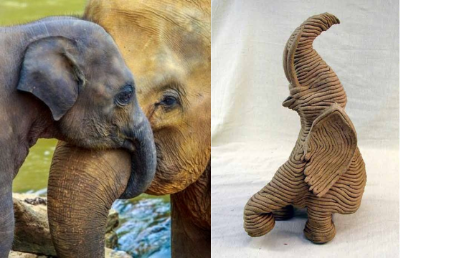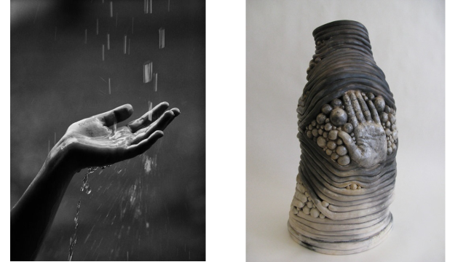
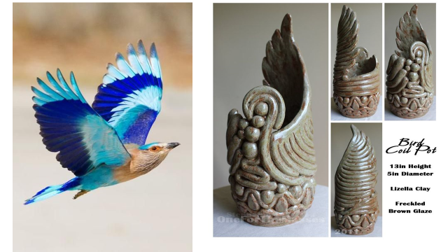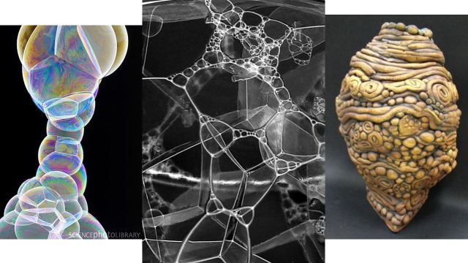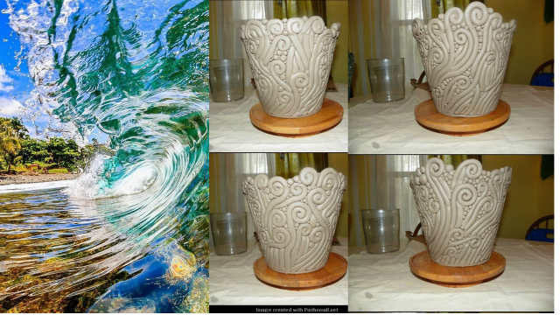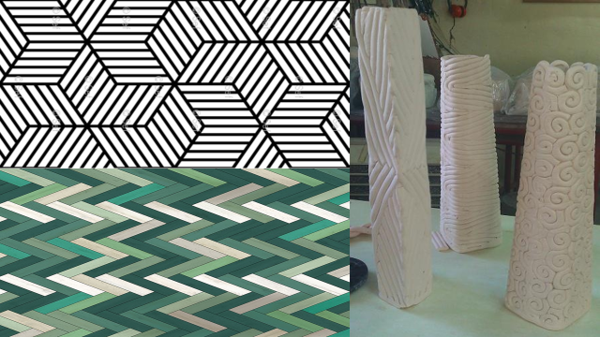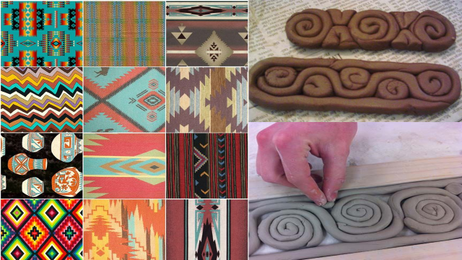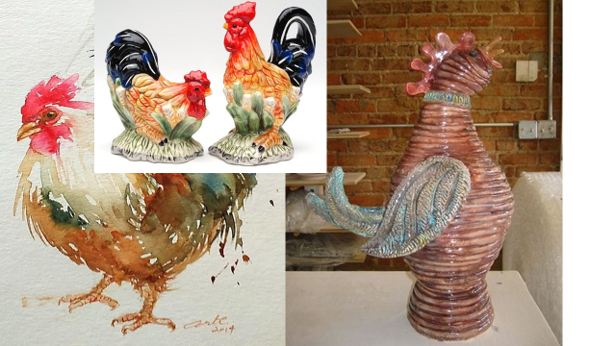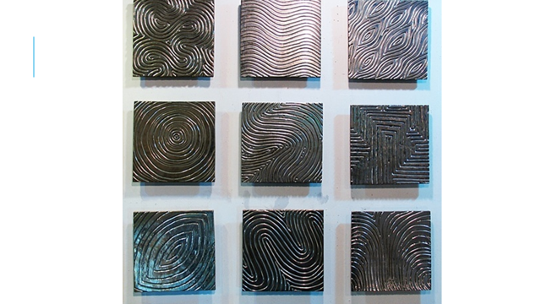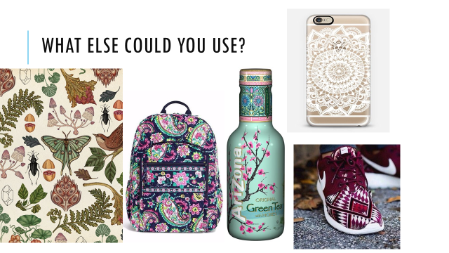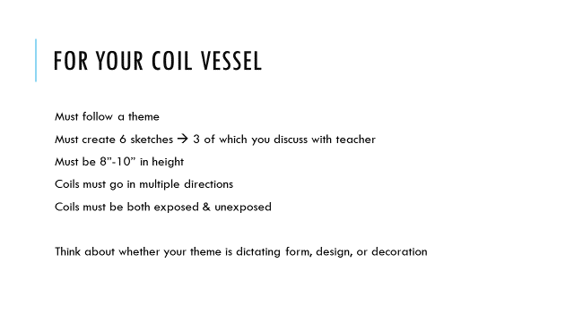

Preparation:
(What do you need to prepare for this experience? List steps of preparation in a bulleted format.)
Day 1:Powerpoint demonstration (teacher) ideation sketches (Students)
Day 2: Sketches and chosen themes due (students) demo materials and demo station for coil pot (teacher)
Day 3-10: Work days
Day 11: Glazing Demo
Day 12: Glaze Work Time
Day 13: Critique

Safety:

(Be specific about the safety procedures that need to be addressed with students. List all safety issue in a bulleted format.)
Students need to make sure that they are using all of the equipment properly so they do not hurt themselves. Students must place newspaper or scrap paper down as a protective surface for glazing. Students must properly dispose of and clean up glaze. Do not ingest glaze, wash off of skin if glaze comes in contact. Glaze is okay to touch.

Action to motivate/anticipatory set:
(Describe how you will begin the lesson to stimulate student’s interest. How will you pique their curiosity and make them interested and excited about the lesson? What inquiry questions will you pose? Be specific about what you will say and do to motivate students and get them thinking and ready to participate. Be aware of the varying range of learning styles/intelligences of your students. Some ideas might include: presenting a skit, telling a story, posing a series of questions, role-playing, etc.
Motivation: Students will view a PowerPoint full of interesting themes and coil pots to match. The coils pots will be inspired by interesting themes and also everyday objects (backpacks, shoes, etc.) Students will be able to find an image to show their theme or they can bring in a personal item. I will explain the process as a time to create unique, fun, and individualized designs. Theme can influence form or design. Students will see completed coil pots to show final transformation of ideas to clay.

Ideation/Inquiry:
(Ideation is the creative process of generating, developing, and communicating new ideas, where an idea is understood as a basic element of thought that can be visual, concrete or abstract. List and describe inquiry questions and processes you will engage students in to help them develop ideas and plans for their artwork.)
- 1. The students will view a PowerPoint demonstration to hook attention.
- 2. The students will sketch ideas for coil pots and have interview with teacher to finalize ideas.
- 3. Student will be creating a coil pot with a designated theme and the pots will be glazed.

Procedures: (Align with instructional methodologies and approximate times for instruction.)
Give a detailed account (in bulleted form) of how you will present the lesson logically and sequentially (include approximate time for each activity). Include motivation and ideation/inquiry where appropriate.)

Day 1:
 | Teacher | Students | Time
 | Day One:  - Attendance & Announcements  - Introduce Project: Coil Vessel  - “We will begin this new project to master the coil technique, and create our first project out of clay. You all will be completing coil vessel with a chosen theme. Your theme may dictate form, function, or design.”  - PowerPoint presentation to spark ideas (attached)  -Talk about the differences of exposed coils vs. unexposed coils (smoothed)  -discuss theme ideas, everyday ideas, exposed coils, unexposed coils, possible outcomes, mistakes  -Discuss different coil techniques (spirals, varying thickness, negative space, etc.)  - Show previous class examples provided by me to inspire and hook students in.  - Explain ideations methods:  “Using your sketchbook you will be creating at least 6 sketches, 3 preliminary sketches will be discussed with teacher to show your ideas and thought processes on this project. Sketches must be at least half a page and must be labeled with the theme. For example: an elephant coil pot can either look like an elephant in its form, or emulate the texture of elephant’s wrinkly skin and not dictate the form.)  - Discuss remainder of project:  “Once themes and sketches have been checked by teacher, you will be cleared to start. Please do not start without checking off your ideas and having one-on-one discussion to approve coil ideas. Okay so that presentation should have given you some ideas of what you may want your coil pot to look like. Do you want your coils to show completely? Do you want to have some decorative coils in the piece that are more formal than functional? I am having you complete so many sketches because the more ideas you have to choose from, the better your coil pot will be when it comes to artistic problems and problem solving along the way. I can’t tell you how many times I thought my first idea was the best and it ended up being disappointing and I wish I would have done something else. I do not want you drawing just one nice sketch and rushing the rest. Take your time! Create and incorporate important details. Push your themes! I also have some suggestions for the shapes of your pot. Try to create interesting shapes, and create pots that are compositionally interesting. (rule of thirds, slinky pots, etc.)”  - Allow the rest of class for research and project discussion.  - Students must show teacher at least 3 sketches with matched themes to discuss and narrow ideas down to one coil sketch.  - Clean Up: Students know their clean up duties & daily clean up routine. | Listening Critically  Students will listen to class introduction and conduct individual research to create a theme they will be building their coil pot from.  Thinking Independently | 5 minutes  15 minutes  10 minutes  50 minutes  10 minutes
 | Day Two:  - Demonstration of coil technique:  - Teacher will do a demo of rolling coils  - Show students where supplies are (tools, water dishes, how to get slip)  - Roll a quick slab and cut out circle from the bottom (Students will be addressing slab techniques later on)  - Demonstrate how proper coils are rolled  - Show mess up and re-roll (air bubble, too think, too thick, push too hard, put too much time on one spot, twist to make weak spot, etc.)  - Slip and score pieces together using clay tools  - Show how placement of coil can control the shape of the pot  - Show smoothing techniques (scraping, paddling, smoothing with fingers, inside, outside)  - Explain the clay allotment (each table gets one bag, take good care, when done for day it belongs on bottom class shelf, roll clay up in ball and moisten, then return to class bag)  - Demonstrate pressing different textures (some created with objects (shoes, keys, foil), some drawn on with tools, & some with added clay)  - Students will then be excused to their seats to create their own coil pot that they have sketched and discussed with teacher. “The goal for these coil pots is to emulate a chosen theme while also allowing time and practice to master the coil technique. Have fun and push your limits! I do not want to see any slinky pots!!.”  - “Please go ahead and get started on your coil vessel. Remember the goal is to be at least 10” high, with coils going in multiple directions. Remember exposed coils and unexposed coils, and think about the profile of your coil pots.  Do you want the designs organic, geometric, deep, or shallow? Patterned or random? There are lots of things to consider when you’re making these.”  - Student Work Time  - When class is over I will discuss the importance of covering a piece well. I will talk about how we want them to be moist so we can continue working on the piece, especially during weekend time. Did you notice while we were working on your coil vessels some of the clay got harder to work with because it was drying out? That is what clay does so make sure you are covering not only your pieces but also your clay. If you do not properly cover your piece it will change to the greenware state and be unavailable to work on. Make sure once you get towards finishing you clean up and clay bits that will fire sharp and also that your name is on the bottom.”  - Clean Up: Students know their clean up duties & daily clean up routine. | Listening Critically  Lecture & demonstration  Independent practice  Students will watch coil demonstration.  Students will begin coil pot project. | 20-30 minutes  40 minutes  10 minutes
 | Day Three-Ten:  *Beginning of class check pots*  - Intro and attendance  - “Everyone please check your coil pot but keep it covered well! We will be watching a Maria Martinez video, who is an advanced potter who is very skilled at creating coil pots. Please come up with ten quick facts, questions, or notes to discuss and show teacher. It is not going to be hard I just want to check for understanding and listening to see what things you learned from her. Hopefully you can relate to her using the coil technique and maybe you can find something to help with your own.”  -make sure the pots are wrapped very well because they will continue working in the future.  - Clean Up: Students know their clean up duties & daily clean up routine. | Listening Critically  Independent practice | 5 minutes  20 minutes  65 minutes  10 minutes
 | Day Eleven:  - Introduction & Attendance  - Announcements: “Today will be a work day! Please continue working on your texture tiles and feel free to raise your hand and ask questions.”  - I will walk around the room offering help, and giving ideas for textures they can use.  - As students continue to build their coil pots, students will come into challenges and frustrations. Reassure students throughout.  Clean Up: Students know their clean up duties & daily clean up routine. | Listening Critically  Visual demonstration  Thinking Independently | 15-20 minutes  60 minutes  10 minutes
 | Day twelve:  *fire coil pots*  - Attendance & Introduction  - Home Room video announcements (in the shared my computer folder)  - Glaze demonstration:  - -Students must cover entire table in butcher paper and or newspaper.  - –using paint sticks mix glaze entirely before using  - -Grab your coil pot and place at seat  - Take handout of glaze notes  - Show students step by step instructions on how to glaze (clean off dust so glaze with adhere properly, discuss techniques: dipping, dripping, brushing, and also blocking off areas.)  - Demonstrate wiping off bottom and discuss why there must be no glaze where pot will touch kiln shelf. Glaze will fuse the shelf and student will have to break piece off shelf and grind shelf down. If too much glaze is applied to piece, crawling will happen and glaze will crawl right off the piece and onto the shelf. If there is too much glaze on shelf to be grinded off, student must purchase new kiln shelf.  - Discuss glaze contamination: DO NOT mix glazes or even brushes! Use dixie cups to take a small amount of glaze back to your seat.  - Student glazing day  - Walk around and ask questions about glazing choices.  - When students finish their glazed piece, show them which shelf to store it on. If the piece is wet they must put newspaper underneath it. *ALL BOTTOMS MUST BE CLEANED COMPLETELY. If they are not the piece will not be loaded into the kiln.  - If students finish very early then they can work on glazing extra fun day pieces.  - Clean Up: Students know their clean up duties & daily clean up routine. | Listening Critically  Demonstration  Developing Confidence in Reason  Students will match colors to their reference.  Noting Significant Similarities and Differences  Students discuss individual choices. | 15 minutes  20 minutes  45 minutes  10 minutes
 | Day Thirteen: Critique Day  - Introduction and Attendance (video announcements)  - Discuss critiques  (Remember: This is majority of the students’ first art class and first critique ever. Many do not know how to participate in a critique and will need encouragement/ideas)  What is a critique? Who has participated in a critique? Tell me what it was like?  Good critique vs bad critique talk  Who has participated in a good critique? Bad?  Language and what to look for  What kind of language do you use in a critique to participate? (EX: I like this… Why?)  Discuss Participation: I have my class list and will be taking note of who participated in this class discussion. 20% of final project grade is this critique/ you must participate with comments &/or questions, you may choose to stay silent but you will be losing 10pts.  (Think about it: You don’t have to take the input of another classmate if it is not for you, positive language for feedback, critical language for feedback, putting your thoughts into questions)  *Pull out example and begin to discuss formal aspects of coil pot to give students ideas*  - Have students walk around the room. Encourage to make notes about interesting coil vessels or ones that caught their eye.  - Students will receive a peer critique handout to guide a scavenger hunt critique. This critique will be mixing informal and formal techniques to discuss thoughts and ideas to reflect upon.  Students must find an example of a coil pot that demonstrates…  Effectively used exposed coils  (Coils are visible in an interesting way, coils are even or intentionally vary sizes)  Effectively used unexposed coils  (Even smoothness, looks intentional)  Used glazes effectively  (No clay body showing, application even throughout, glaze enhances piece)  Shows beautiful craftsmanship  (No finger prints, clay bumps, cracks, or clay body showing)  Shows a clear/obvious theme present  (Direct connection to the ocean, trees, animal, etc.)  Is a creative coil pot  (Original design, interesting to look at, possibly your favorite)  - “Remember, you may share with others at the end of what you found interesting. Please do your best to focus on what you feel connects best with yourself. Please aim for 3-5 complete sentences per piece.. Don’t forget to explain WHY!”  - Remind students, “No one should finish doing this quickly. Spend up to five minutes on each vessel, writing down all the thoughts that come to your mind. Think about what you are trying to say before you start writing. These thoughts can be about what you like, just explain why. These thoughts can be questions, or even just how you feel about the piece.”  - Regroup class together and allow 5 minutes for group discussion at tables about which pieces stood out to them.  - Attention: Ideas for group discussion. Students will hopefully volunteer to share their thoughts at the end, to facilitate in an in class discussion, touching on more formal aspects of a critique. (Here I will need to reassure students / give ideas of aspects of pieces that students can talk about.)  - Students will complete self-assessment: Please fill out your self-assessment only if your coil vessel is ready to be turned in. If you are re-firing your vessel, please wait and turn in self-assessment with final piece.  - Student will turn in self-assessment along with peer critique sheet | Listening Critically  Demonstration  Developing Confidence in Reason  Students will match colors to their reference.  Noting Significant Similarities and Differences  Students discuss individual choices. | 10 minutes  5-8 minutes  2-5 minutes  30 minutes  5 minutes  15-20 minutes  10 minutes

Student reflective/inquiry activity:
(Sample questions and activities [i.e. games, gallery walk, artist statement, interview] intended to promote deeper thinking, reflection and refined understandings precisely related to the grade level expectations. How will students reflect on their learning? A participatory activity that includes students in finding meaning, inquiring about materials and techniques and reflecting about their experience as it relates to objectives, standards and grade level expectations of the lesson.)
Students will set out coil pots and participate in a critique. In this critique student will write down their thoughts and ideas on their classmates’ pieces, using a provided critique guide. At the end of class we will regroup for a group discussion, discussing any ideas, thoughts, or suggestions. Students will also complete a self-evaluation for their coil pots. This is to ensure teacher and student are on the same page about the project.

*Please Refer to Peer Critique Sheet & Self-Evaluation Attached*

Post-Assessment (teacher-centered/objectives as questions):  (Have students achieved the objectives and grade level expectations specified in your lesson plan?) | Post-Assessment Instrument:  (How well have students achieved the objectives and grade level expectations specified in your lesson plan? Rubric, checklist, rating scale, etc.)
Teacher Centered Assessment  Name:____________________________________________-  Evaluation for Coil Vessel  __/20 Directions  Were all the brainstorming activities and preliminary sketches completed on time?  Do the coils go in multiple/different directions?  Does the piece meet the height requirement of 8”-10”?  __/20 Craftsmanship  Is the coil pot well-made?  Are the coils neatly placed and not sloppy?  Did your piece survive through all firings?  Does the chosen glaze go well with the piece?  Was the placement of glaze/colors well thought out?  Is the entire clay body covered with glaze?  __/20 Design  Is the pot creative and interesting to look at?  Does the chosen theme go with the design of the coil pot?  Does the design seem to be intentional and not happen by chance?  __/20 Effort and Attitude  Was class time used wisely? (Student always working to complete project, not disturbing others.)  Were the deadlines met throughout the process of the  project?  Did the student always come on time prepared to class with  ideas and supplies?  Does the student participate in clean up without being  asked and help others?  Did the student ask questions to better their projects?  __/20 Critique  Was participation in critique voluntary? (Constructive  comments and questions throughout)  Did you fill out peer critique with full sentences and detail?  Total: ___/100  Additional Comments: | Student Centered Assessment  When students finish critiquing classmates they will grade themselves along with the teacher grading them to ensure both teacher and student are on the same page  Name:____________________________________________-  Self-Evaluation for Coil Vessel  __/20 Directions  Were all the brainstorming activities and preliminary sketches completed on time?  Do the coils go in multiple/different directions?  Does the piece meet the height requirement of 8”-10”?  __/20 Craftsmanship  Is the coil pot well-made?  Are the coils neatly placed and not sloppy?  Did your piece survive through all firings?  Does the chosen glaze go well with the piece?  Was the placement of glaze/colors well thought out?  Is the entire clay body covered with glaze?  __/20 Design  Is the pot creative and interesting to look at?  Does the chosen theme go with the design of the coil pot?  Does the design seem to be intentional and not happen by chance?  __/20 Effort and Attitude  Was class time used wisely? (Student always working to complete project, not disturbing others.)  Were the deadlines met throughout the process of the project?  Did the student always come on time prepared to class with ideas and supplies?  Does the student participate in clean up without being asked and help others?  Did the student ask questions to better their projects?  __/20 Critique  Was participation in critique voluntary? (Constructive comments and questions throughout)  Did you fill out peer critique with full sentences and detail?  Total: ___/100  Additional Comments:  Would you keep this piece? Why or why not?  What did you do well?  What would you improve on?  What did you learn or experience from this project?  Is this a good project for 3D Design?

Self-Reflection:
After the lesson is concluded write a brief reflection of what went well, what surprised you, and what you would do differently. Specifically address: (1) To what extent were lesson objectives achieved? (Utilize assessment data to justify your level of achievement.) (2) What changes, omissions, or additions to the lesson would you make if you were to teach again? (3)What do you envision for the next lesson? (Continued practice, reteach content, etc.)
This lesson went very well, especially since it was many students first time ever working with clay as a material. Here the students reached the objectives by using ideation to create a theme, incorporating coils, slip, and score techniques to build a 10” vessel, and also using inherent characteristics and features of art to critique the coil pots. During the critique process, the students completed a self-assessment to ensure all objectives were met entirely and also so the student and I were on the same page for their final grade for the coil project. It surprised me how challenging it was for students to come up with a theme. I imagined the ideation process to be the easiest part but many students were so invested in their ideas they had a hard time making a decision. This showed that the ideation process was challenging for all students, which of many was their first art project ever. I created a height requirement so students would step out of their comfort and push their building abilities, which could have been more successful. Due to the height requirement, some students came into building and technical skill issues that came apparent during the bisque firing. Some coil pots cracked, fell apart, and exploded, which I tried to avoid but it was inevitable from lack of experience with clay and also the time restrictions we had for a firing cycle. What worked really well was how invested the students were in this project once they decided on a theme. The students were all engaged and persistent throughout the project steps and processes. Many students went above and beyond with this project which worked very well. Some students pushed height, form, and also glaze choices, which ended up making their pieces most successful. If I were to teach this lesson again, I would do everything the same except I would also create a written outline of the PowerPoint so the students had the requirements in front of them at all times. Students were required to take notes but not all of them wrote down everything they needed. With an outline the students would be able to make sure they fully completed each required step in the building process, while also following all requirements. All forms, decorations, and glazing techniques turned out very well and better than expected for students’ first clay project. Overall this was a very successful lesson, especially as a beginning project, and I would teach this clay project again for continued practice in clay.

